
HFPD Operator Guide

By: Eric Landes
Rev 1.1
Created: 10/25/2019
Last Revision: 10/31/2019
Table of Contents
Introduction 3
Hands-Free Pager Device Hardware 4
HFPD Display 4
Logo Section 4
Shift Mode Section 5
Information Section 5
Message Section 5
HFPD Button 5
HFPD Speaker 5
Device Operation 6
Device Configuration 6
Associating with Operators 6
Hands Free Login App 8
Configuring a Hands-Free Pager Device 10
Fields and Settings 11
Messages 14
Firmware 15
Alerts 17
Alert Configuration 17

Introduction
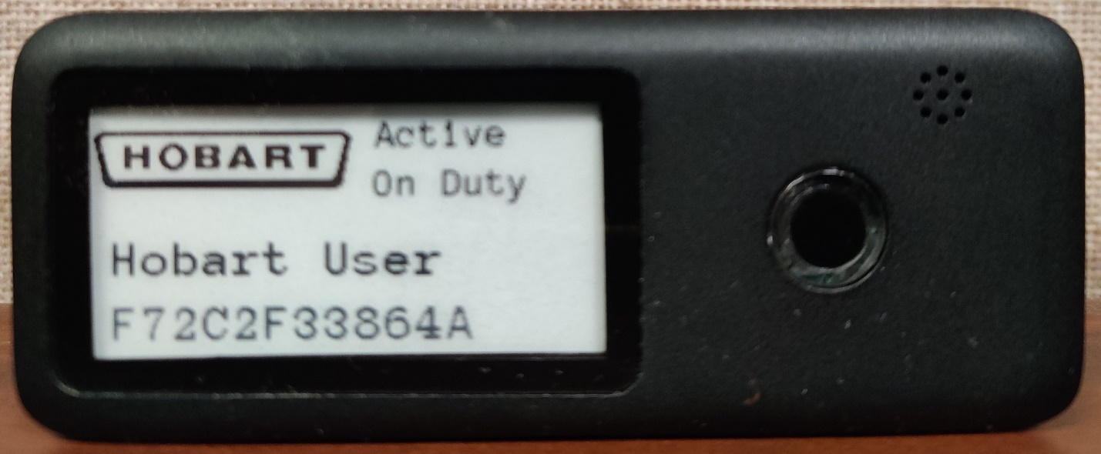
Figure 1: The HFPD device
The Hands-Free Pager Device (HFPD) is used to log into and notify the user of issues with Hobart equipment. The purpose of this document is to inform the user on how to properly configure and use the HFPD. The following steps assume that the scale in use has the _SCALE_HANDSFREEDEVICE license and the hti-linux-feature-hfpd feature installed.

Hands-Free Pager Device Hardware
On the front side, the handsfree device has three main components, the display, the speaker, and the button.

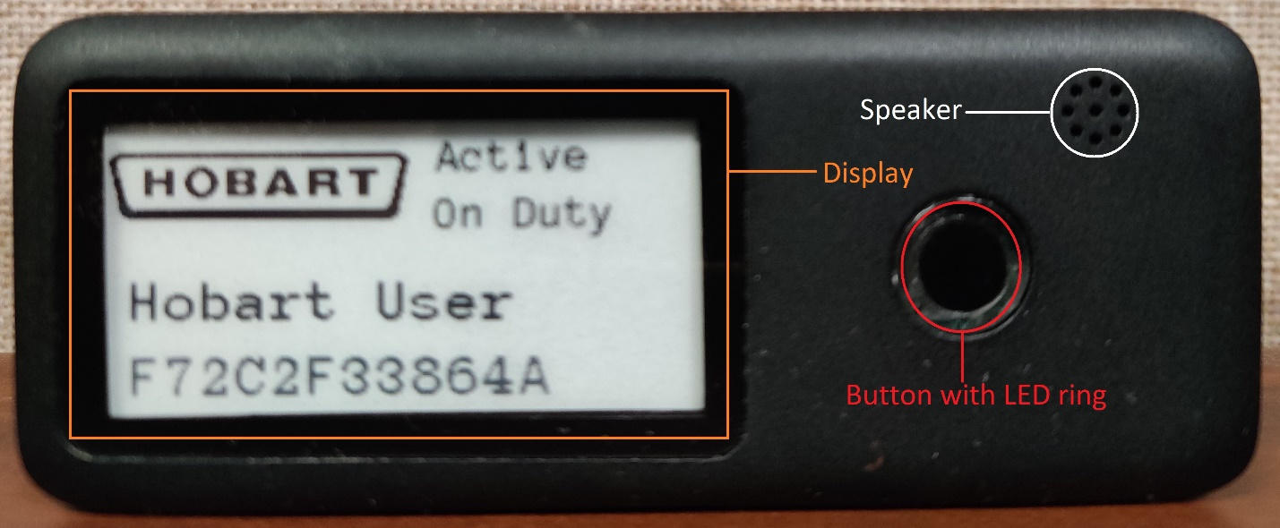
Figure 2: The Sections of the HFPD

HFPD Display
The HFPD is equipped with an e-ink display. The display is used to display messages and status information about the beeper. The display is split into four sections, the logo section, the shift mode section, the information section, and the message section.
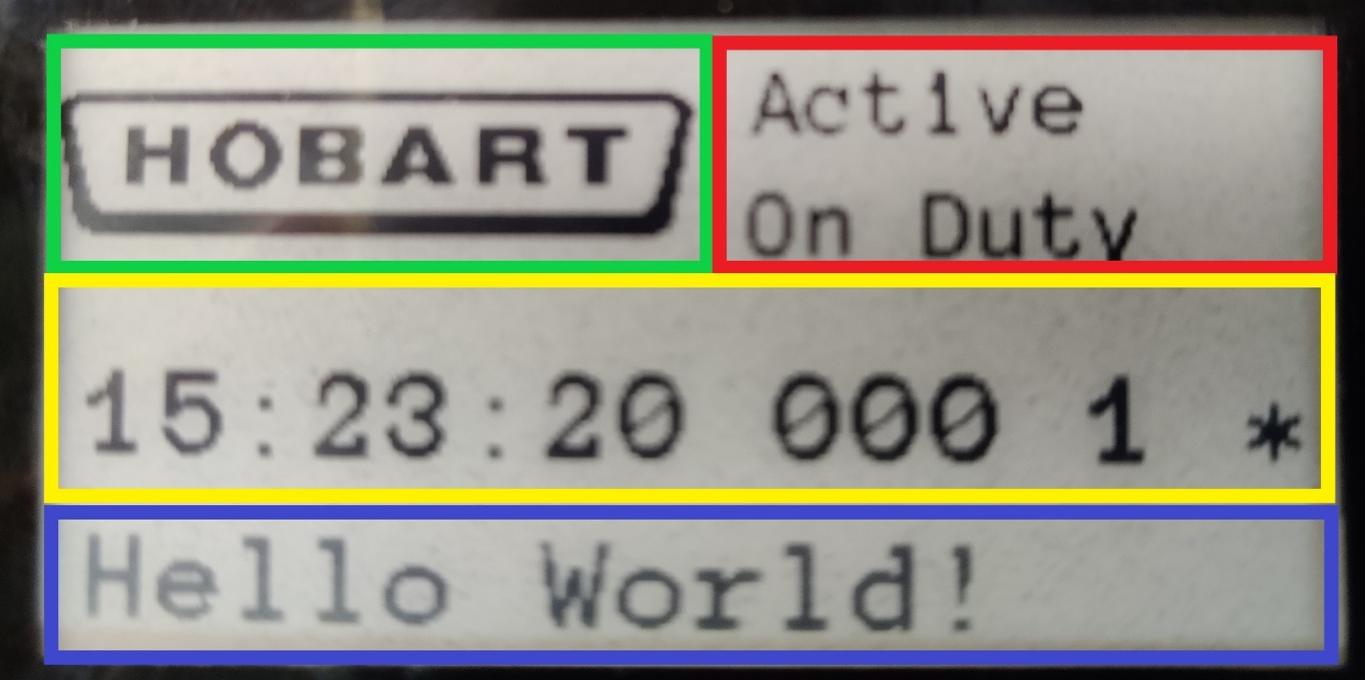
Figure 3: The Sections of the HFPD display

Logo Section
The logo section, highlighted by the green box in Figure 3, displays the company logo. The logo can be set using the Hands Free Login app.

Shift Mode Section
The shift mode section of the device, highlighted by the red box in Figure 3, tells if the device is currently active or inactive. For more information about active and inactive mode see Device Operation. The shift text can be configured using the Hands Free Login app.

Information Section
The information section, highlighted by the yellow box in Figure 3, displays information about the recently received message or the user name associated with the device. If there is no message the user name is displayed. If there is a message displayed on the screen the information section displays the time the message was sent, the scale that sent it, the number of messages queued and, the status of the device. In Figure 3 the information section displays ‘15:23:20 000 1 *’. The first section, ’15:23:20’ represents the time the message was sent. The second section, ‘000’ is the scale number. ‘1’ is the number of messages on the queue, and the ‘*’ is the status of the scale. Possible status symbols are displayed in Table 1
Table 1:Status Symbol Definitions
Status Symbol | Description
‘!’ | Low Battery
‘>’ | Message queue overflowed
‘<’ | One or more messages queued
‘*’ | Message queue empty

Message Section
The message section, highlighted by the blue box in Figure 3, displays the oldest message in the queue. If multiple messages are queued the user must press the HFPD Button to clear the displayed message and see the next.

HFPD Button
The button, illustrated in red in Figure 2, is used to dismiss messages and switch between active and inactive modes. When a message is sent to the device it will be displayed on the Message section of the HFPD Display. To clear this message press and release the button. Clearing one message will display the next queued message if one exists. The button can also switch the device between active and inactive modes. To switch between modes, hold the button for approximately two seconds. The device will then beep and refresh the display. Embedded in the button is a LED ring. The LED ring will slowly flash when the device battery is less than 10%.

HFPD Speaker
The speaker, highlighted in white in Figure 2 is used to notify the user of new messages, and key presses. The speaker can be configured using the Hands Free Login app.

Device Operation
The Hands-Free Login device has two different modes of operation, active and inactive. In active mode the device broadcasts its information for Hobart equipment to pick up. This allows Hobart equipment to connect to the HFPD to send messages and update configuration. The HFPD must be in active mode to enable automatic login. To save battery, the device can also be put into an inactive state. In the inactive state the device does not broadcast its information and will not receive any messages.

Device Configuration
In order to configure HFPD and operators the _SCALE_HANDSFREEDEVICE license must be installed.

Associating with Operators
Associating the HFPD with a scale operator allows the user to be automatically logged in when they approach the scale and then automatically become logged out when they leave the scale. Completing the following section will associate an operator with a HFPD.

Navigate to the “Supervisor Pages” menu and then press the blue “ALL FUNCTIONS >” button near the bottom of the screen. This will bring up the full supervisor menu illustrated in Figure 1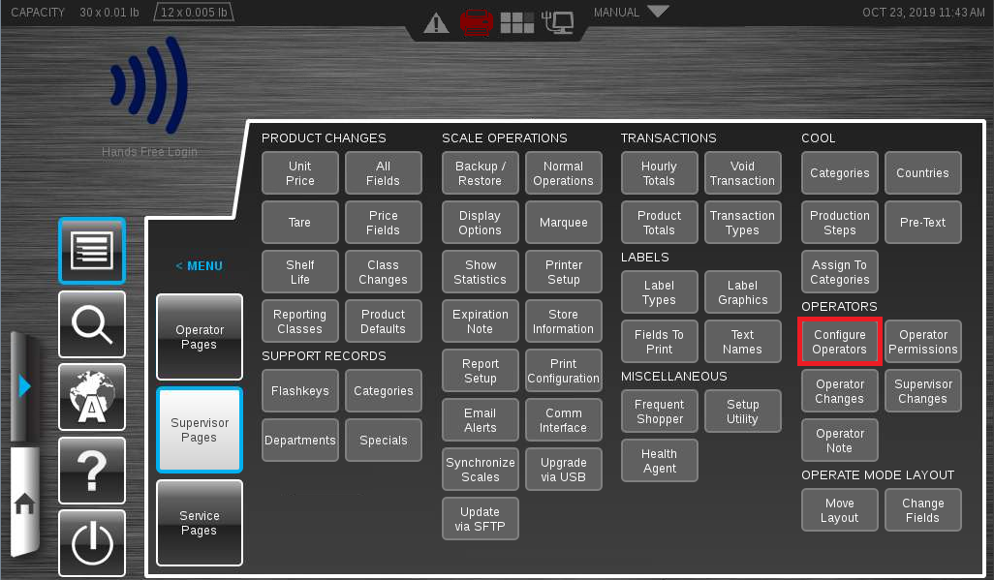
Figure 4: The expanded "Supervisor Pages"
After expanding the “Supervisor Pages” press the “Configure Operators” button highlighted in Figure 1. This will bring up the Operator Configuration page shown in Figure 2.
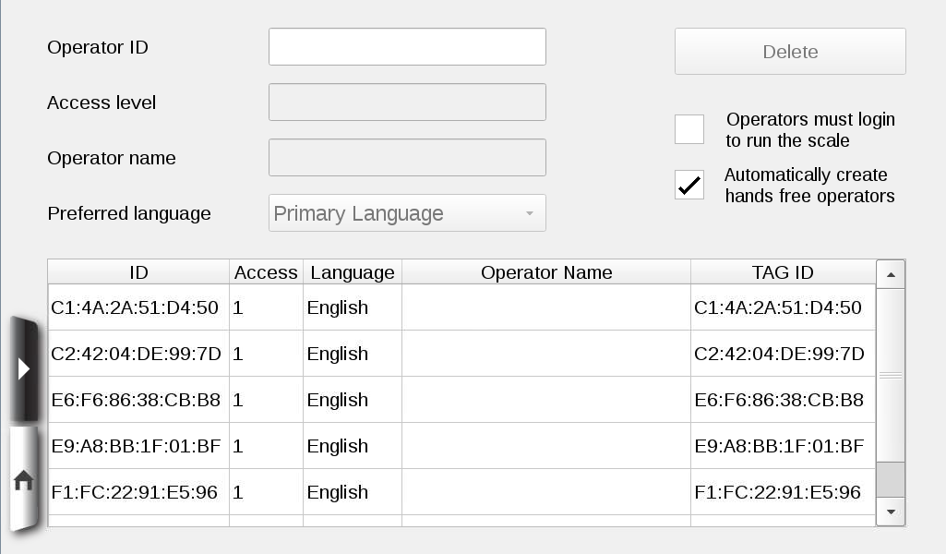
Figure 5: The Operator Configuration Page
Once the Operator Configuration page is displayed select by pressing the Operator ID that matches the MAC address of the HFPD you are trying to associate with. The mac address can be found underneath the batteries in the battery compartment, or in the message field after a device reboot. After selecting an operator, fill out the Access Level, Operator Name, and Preferred language to their desired values. The “Automatically create hands free operators” checkbox will cause the scale to automatically detect and create operators for each HFPD within range.
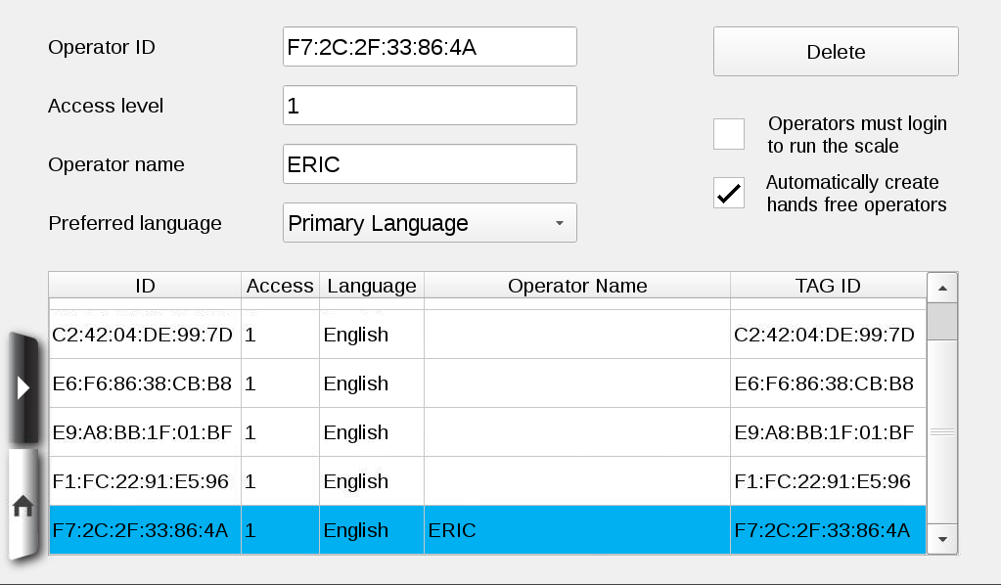
Figure 6: A configured operator
Once the HFPD is configured as desired, return to the home screen to complete the association process.

Hands Free Login App
The Hands-Free Login App is used to detect and configure HFPDs. Through the app you can change fields and settings, send messages, and update firmware for HFPDs. The Hands-Free Login app is installed and licensed by Hobart Technicians. To run the Hands-Free Login app, you must first swipe down from the top of the screen. This will bring up the app tray. Once the app tray is displayed, locate and press the Hands-Free Login app. In order to use the Hands-Free Login App you must have the _SCALE_HANDSFREEDEVICE licenses installed 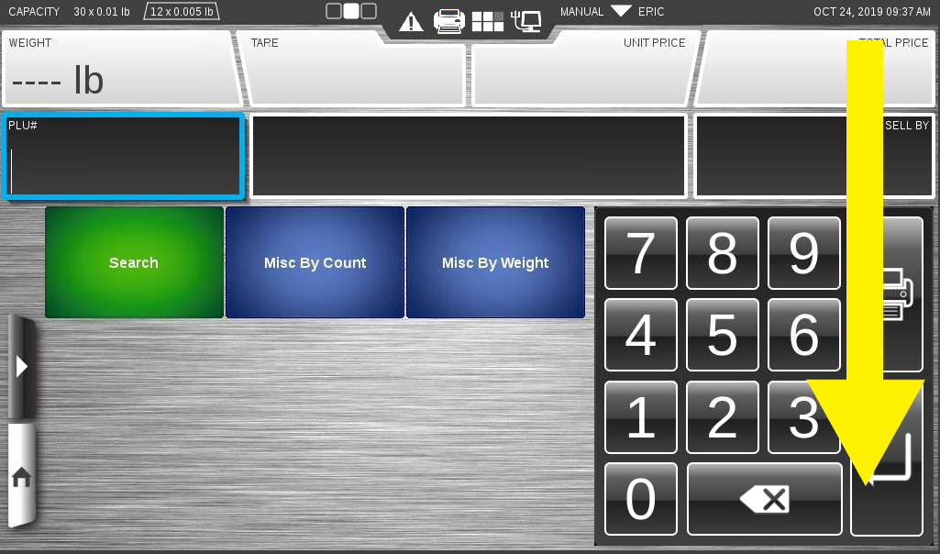
Figure 7: Swipe down to show the app tray
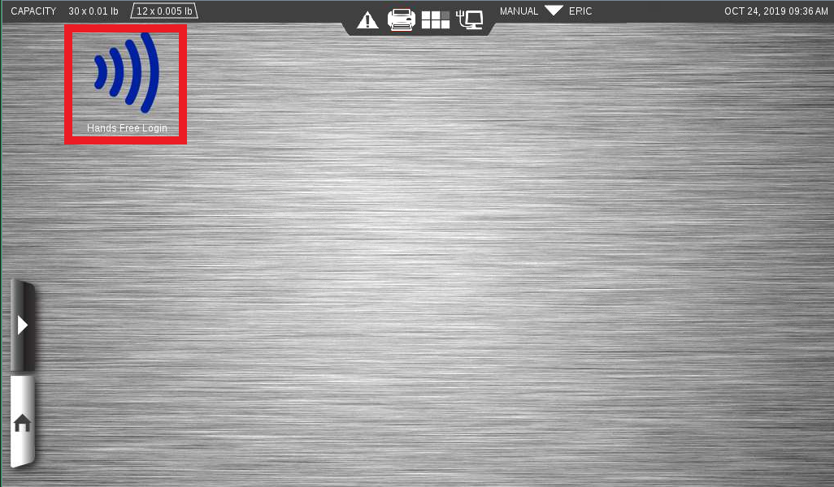
Figure 8: The hands-free login app (Highlighted in red)

Configuring a Hands-Free Pager Device
To configure a HFPD, you must first detect the device using the Hands-Free Login app. First open the Hands-Free Login app. Once the app has loaded it will display the device discovery screen shown in Figure 9.
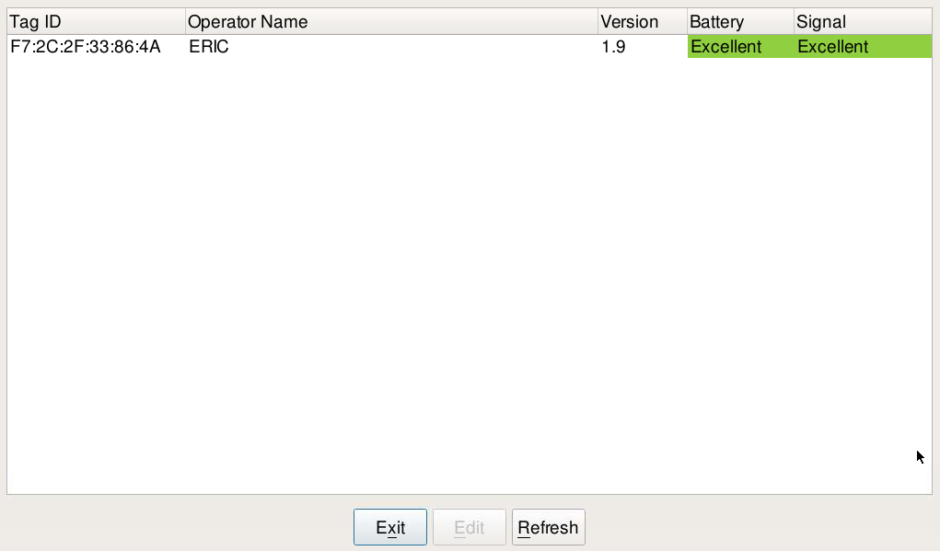
Figure 9: Hands Free Login app device discovery screen
To modify device configuration, press the row containing the TAG ID matching the MAC address of your device, and then press the Edit button. This will take you to the device configuration screen. 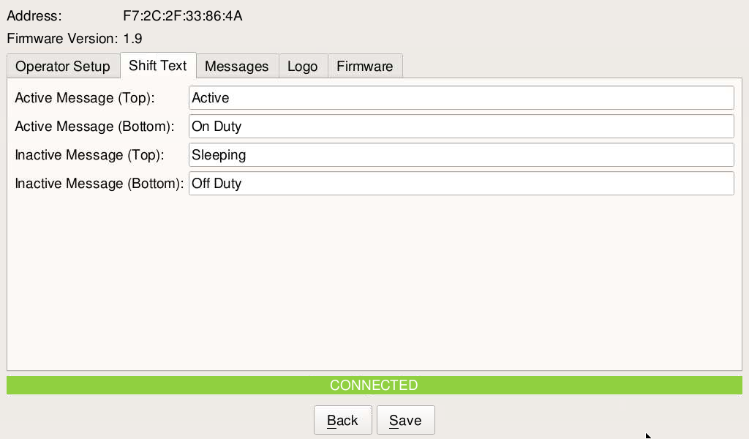
Figure 10: The Device Configuration screen

Fields and Settings
The Hands-Free Login app provides a method for configuring HFPD fields and settings. On the app’s Device Configuration page, three tabs are used to configure HFPDs. They are the “Operator Setup”, “Shift Text” and “Logo” tabs.

Operator Setup
Figure 11 shows the Operator Setup tab. This tab allows the user to set the Operator Name, Shift Duration, and Beep Time.
The Operator name is displayed on the HFPD when no messages are displayed on the device. The operator name is restricted to 16 characters due to space constrains of the screen.
Shift Duration is used to automatically change the to sleeping mode after the set time is reached. Shift Duration can be any whole number value between 0 and 36 hours. Setting the Shift Duration to 0 disables the timer.
Beep Time specifies the duration of the beep when a message is received, or the button is pressed. The Beep Time can be set to any whole number between 0 and 255. Setting the value to 0 silences the beep timer.
After filling out the desired values press the save button to send the values to the HFPD.
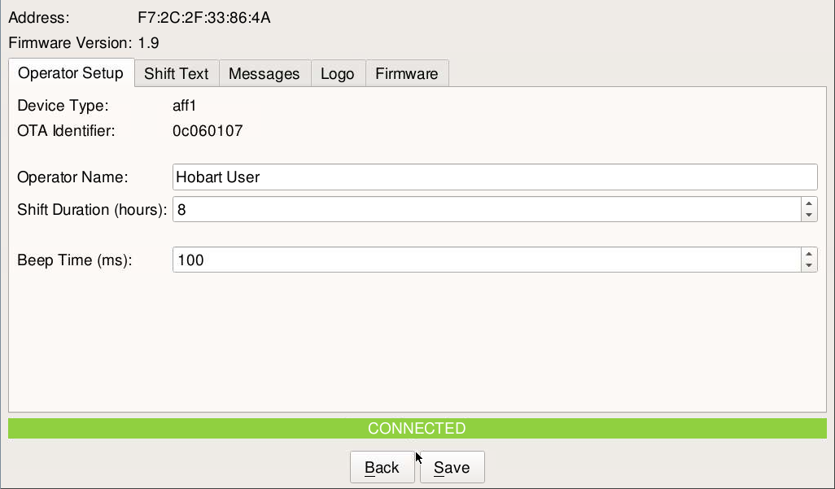
Figure 11: The Operator Setup Tab

Shift Text
Shift text is displayed in the shift text region of the display. It is used to indicate if the device is in an active or inactive state. In the shift text region, there is enough space for two lines containing ten characters each. The Active Messages are displayed when the device is active and receiving messages. The inactive messages are shown when the device is in low power mode and not receiving messages. After Filling in the desired values for Active and Inactive messages, press save to send the values to the HFPD.
Figure 12: The Shift Text Tab

Logo
Users can upload images to be displayed in the logo section of the HFPD display. The optimal logo resolution is 128 x 48 pixels. Images other than this size will be shrunk to this resolution and may be cropped. Acceptable file formats for logos are .bmp, .gif, .jpg and .png. To upload a new logo, navigate to the Logo tab on the Device Configuration page. Select the desired logo by typing the path to the Logo Filename box, or by clicking the button with three dots (” …”) at the end of the box. Clicking the button will bring up a file picker, shown in Figure 14 so the user can search and find the desired logo. Once the logo has been selected press the Upload Logo button to send the image to the HFPD. After receiving the Logo, the HFPD will update its display with the new logo.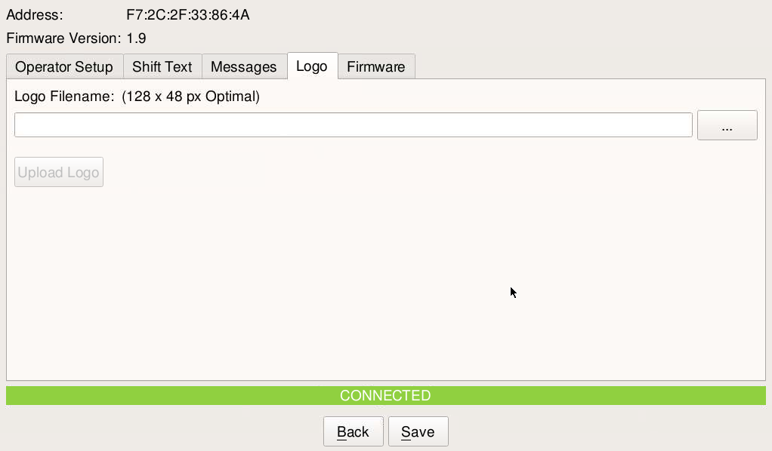
Figure 13: The Logo tab
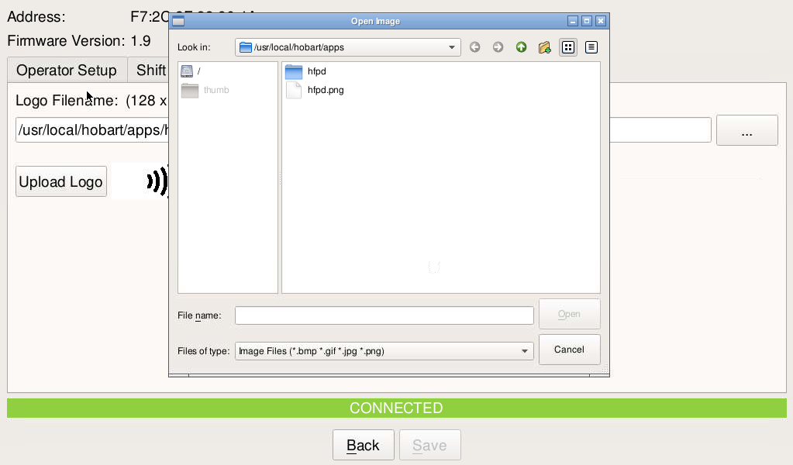
Figure 14: The logo file picker

Messages
The user can send custom messages to HFPD devices and clear all messages on a device using the Messages tab of the Device Configuration page. To clear all messages on a device, navigate to the device configuration page for that device and then select the Messages Tab. On the Messages tab press the “Clear All Messages” button to erase all messages on the device. To send a custom message, fill the Message Text box and then press the Send Message button. The Message field is limited to 16 characters due to display size constrains.

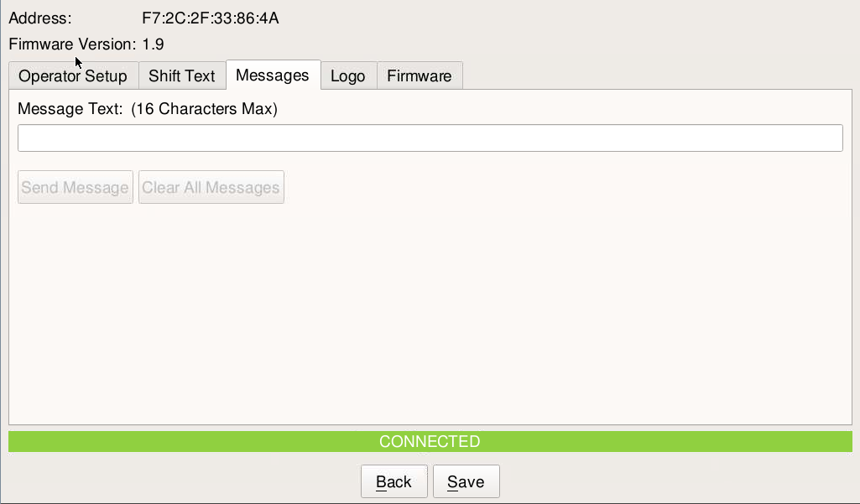
Figure 15: The Messages tab

Firmware
As new features are added and bugs are fixed, new versions of HFPD firmware will be released. The Hands Free Login App provides the ability to upload new firmware to HFPD. Before the firmware can be uploaded to a HFPD, the firmware must first be stored on the scale. Feature files are created to provide an easy route for adding new firmware files. Contact Hobart Service to get the latest HFPD firmware feature files. Feature files should be labeled htseries-any-hfpd-application-*.package.tgz. To add new firmware to the scale, navigate to the “Supervisor Pages” and press the blue “ALL FUNCTIONS>” button near the bottom of the menu. After expanding the Supervisor Pages press the “Upgrade via USB” button. Insert a usb drive containing the feature file into the scale. Press the “Choose Upgrade Firmware File” button, to bring up the firmware file picker dialog. Use the file picker to find and select the HFPD firmware feature. Press “Open” button to finalize the selection and close the file picker. Once the file picker closes press the “Upgrade Firmware” button to start the upgrade. When the upgrade is complete a popup will appear notifying the user of a successful upgrade installation. The upgrade will copy a firmware file named IARHFPD-X.X.zip in the /lib/firmware/hfpd/ folder. Once the firmware file has been installed users can upload firmware to the HFPD using the Hands Free Login app. To upload firmware, open the Hands Free app and edit the device you wish to upgrade. Once connected to the device navigate to the “Firmware” tab. Then press the “…” button to open the file picker. Use the file picker to select the firmware file to be installed and then press open to finalize the selection. Once the dialog has closed press the “Update” button to flash the firmware to the HDFPD. A popup will appear showing the progress of the upgrade will appear and notify the user when the upgrade is complete. 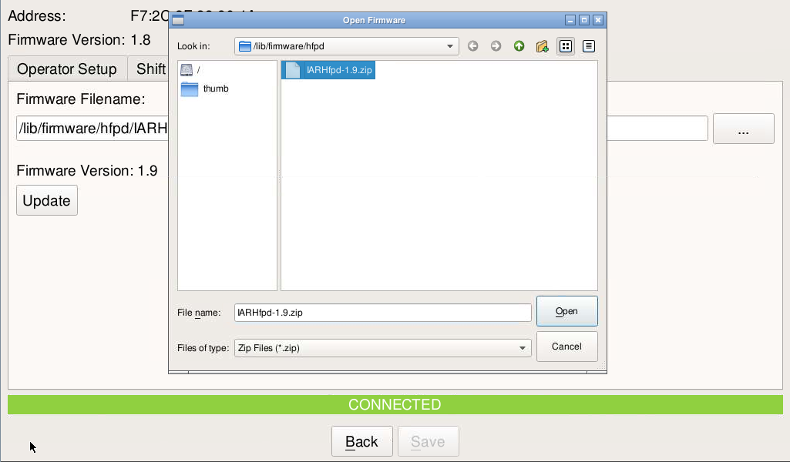
Figure 16: Use the firmware file picker to select the upgrade file

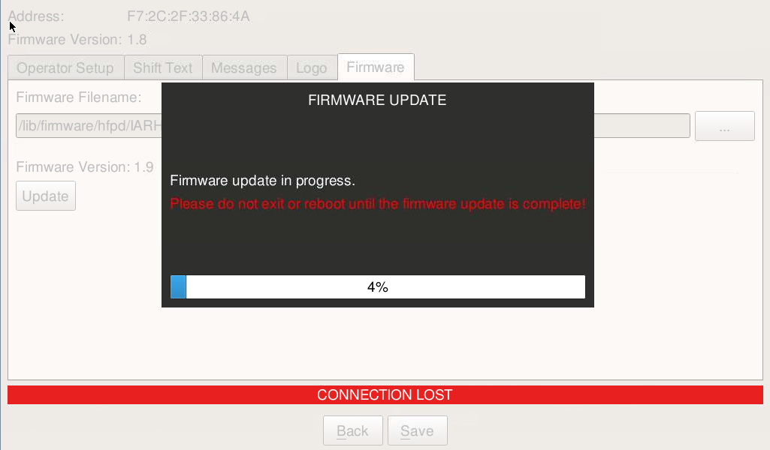
Figure 17: The Firmware Update progress bar

Alerts

Hobart equipment can be configured to automatically send alerts to nearby HFPDs when the equipment encounters an error. Alerts will be sent to all devices within range of the scale. They can be configured to be sent when the issue occurs and when the issue is resolved.

Alert Configuration
To configure automatic alert messages on a scale, navigate to the “Supervisor Pages” and press the blue “ALL FUNCTIONS>” button near the bottom of the menu. After expanding the Supervisor Pages press the “Email Alerts” button illustrated in Figure 16. Once the Email Alerts page is displayed navigate to the “Hands-Free Device Alerts” tab shown by Figure 17. Check the boxes next to the desired alerts to enable the alert for that issue. Checking the “Notify when resolved” box across from the issue will send an alert when the issue is resolved. The delay indicated on the “Email Alerts” tab applies to both email alerts and HFPD alerts.

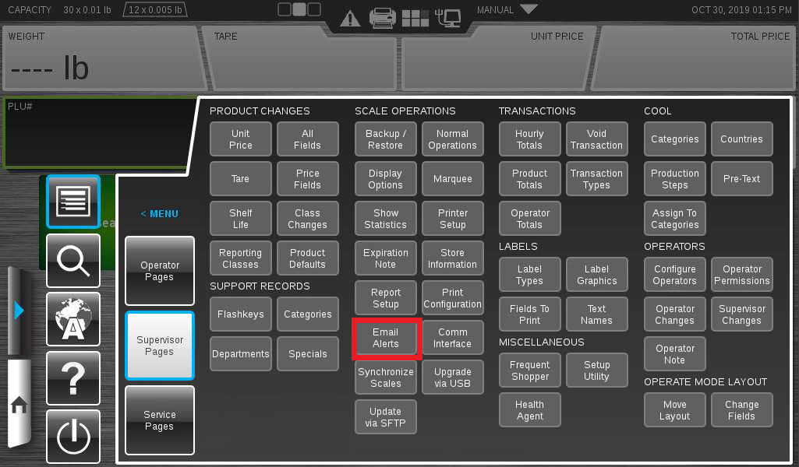
Figure 18: Supervisor Pages Email Alerts
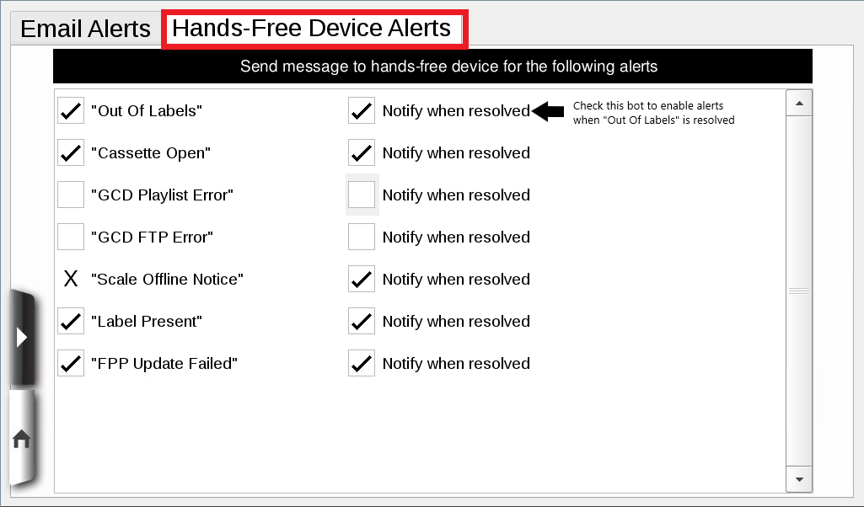
Figure 19: Hands-free Device Alert Configuration Page
When any of the configured issues are detected or resolved, the scale will send a message to all nearby HFPD. The message will start with a “P:” or a “R:” and then will state the error. “P:” is sent when the error is detected and “R:” is sent when the issue is resolved. For example, when Out Of Labels is detected the scale will send “P: Out Of Labels”.

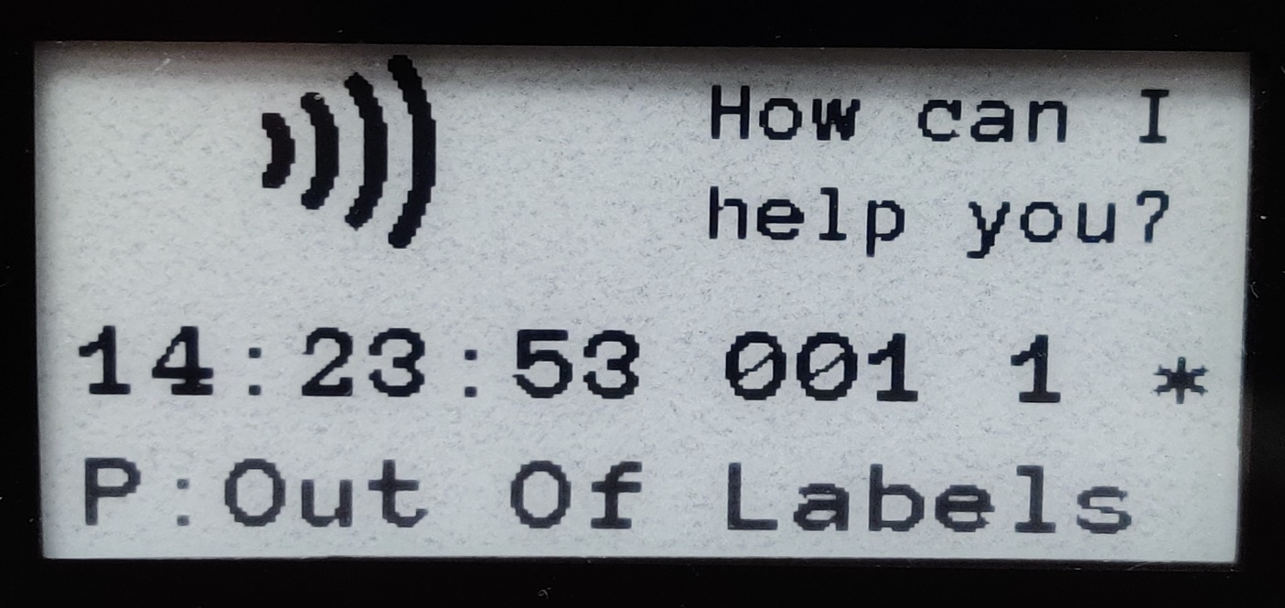
Figure 20: Automatic message for "Out Of Labels" detected

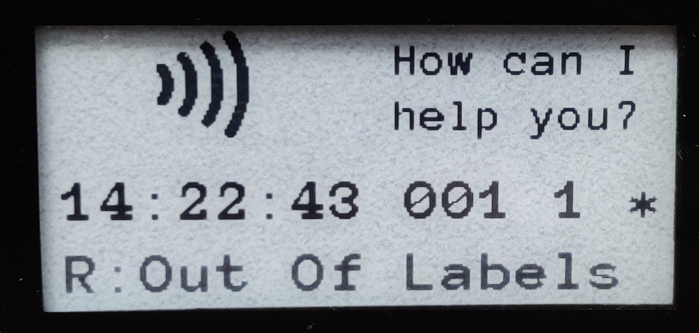
Figure 21: Automatic message for "Out Of Labels" Resolved

